Chapter 4

Computational fluid dynamics

4.1 Computational fluid dynamics
Computational fluid dynamics (CFD) is a branch of fluid mechanics that uses numerical methods and algorithms to solve and analyze problems that involve fluid flows. Computers are used to perform the calculations required to simulate the interaction of liquids and gases with surfaces defined by boundary conditions. With high-speed supercomputers, better solutions can be achieved. Ongoing research, however, yields software that improves the accuracy and speed of complex simulation scenarios such as transonic or turbulent flows. Initial validation of such software is performed using a wind tunnel with the final validation coming in flight tests.
The Program that we used to facilitate the usage of CFD was Ansys Fluent, this program simulates the fluid dynamics around the mechanism allowing you to predict the velocity of wind, temperature and pressure.
The program also allows you to show your answer with graphical curves and contours, which will make easy comparison between different mechanisms.
The Figure below shows the results of Ansys fluent on a blade of a wind turbine, showing high pressure under the blade and low pressure over the blade causing the turbine to rotate.
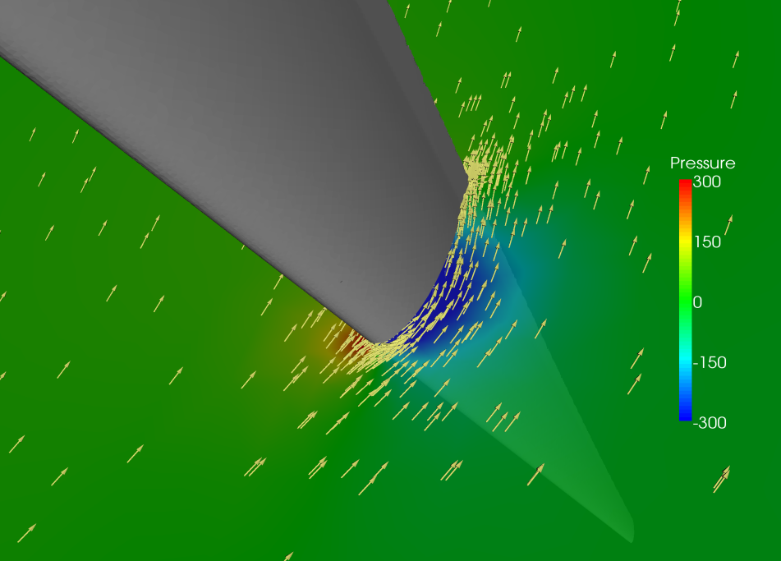

4.2 Background and Applications:
The fundamental basis of almost all CFD problems are the Navier–Stokes equations, which define any single-phase fluid flow. These equations can be simplified by removing terms describing viscosity to yield the Euler equations. Further simplification, by removing terms describing vorticity yields the full potential equations. Finally, these equations can be linearized to yield the linearized potential equations.

4.3 Applications:
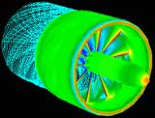•AutoMotive.
•Turbo Machinery.
•AeroSpace.
•Air Foils.
•Mechanical.

4.3.1 Automotive:

Automotive is among the area which mainly use CFD calculation. Car body for design and performance, comfort of an individual in a car by using human body thermoregulatory model that considers the detailed vascular system and individual physiological factors, HVAC systems, transient analysis for reverse flow in intake and exhaust manifolds or thermal simulation considering the material and thickness of the manifold, two fluids computation (air and water or coolant) for the efficiency of heat exchanger such as radiator, inter cooler, oil cooler, water jacket, swirl ratio and/or tumble ratio, all these modelings are today available to address the main fields in automotive application.
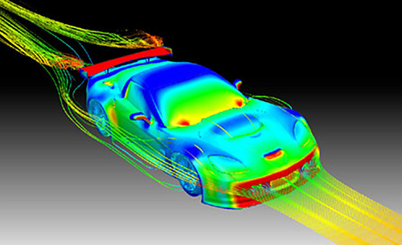
- Vehicle Aerodynamics for design and performance
- Passenger comfort including cabinet climate control
- Defogging and defrosting of windshields
- Air Conditioner Ventilation Duct
- Engine Room Ventilation
- Radiator ventilation
- Side View Mirror
- Manifold
- Heat Exchanger
- Engine

4.3.2 Aerospace
“In today’s context of strong competitiveness, worldwide aircraft, engine and equipment manufacturers are facing greater challenges than ever before. The market demands that more complex products be developed with shorter lead times and more cost effectiveness while using evolving business models involving multiple partners”.
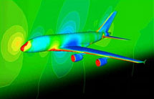

More robust preliminary design and advanced design thus is needed for:
- Having instant, clear, and accurate visibility of the status and performance of the product.

- Fast, accurate exploration of many more product and process design options, to increase value to the customer and reduce lead time and cost.

- Rapid evaluation of alternatives, trends, and risks, based on accurate data, to confidently predict the results of contemplated actions.

- Quickly evaluate issues and options to determine the best compromises.

- Instantly propagate changes to all relevant parts of the enterprise and automatic update of the related enterprise model.

- Rapid optimization of new product designs, processes and equipment, and business operations, to maximize efficiency and profitability while reducing all forms of waste.

- This means

- Reduction of development lifecycle duration and cost.
- Reduction in rework.
- Reduction in the cost of physical tests.

The integration of full CFD in the Multidisciplinary and MDO processes is made easy by reducing the time scale of CFD to the level of other physics.This utopia has become reality, and Fluorem is able today to offer, with his parameterization software Turb’Opty, the bridge to reach “terra incognita” new designs.

4.3.3 Turbo machinery

Flow Modeling Solutions for Turbo machinery:
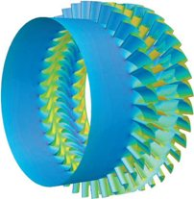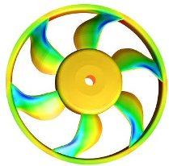
Mach number contour ploys on the pressure contour on the fan hub

Turbo machinery design is driven by the need for improved performance and reliability. Computational fluid dynamics (CFD) can help you achieve these goals.

4.4 Methodology:
In all of these approaches the same basic procedure is followed.

During preprocessing:

- The geometry (physical bounds) of the problem is defined.

- The volume occupied by the fluid is divided into discrete cells (the mesh). The mesh may be uniform or non uniform.

- The physical modeling is defined – for example, the equations of motions + enthalpy + radiation + species conservation
Boundary conditions are defined. This involves specifying the fluid behaviour and properties at the boundaries of the problem. For transient problems, the initial conditions are also defined.

- The simulation is started and the equations are solved iteratively as a steady-state or transient.
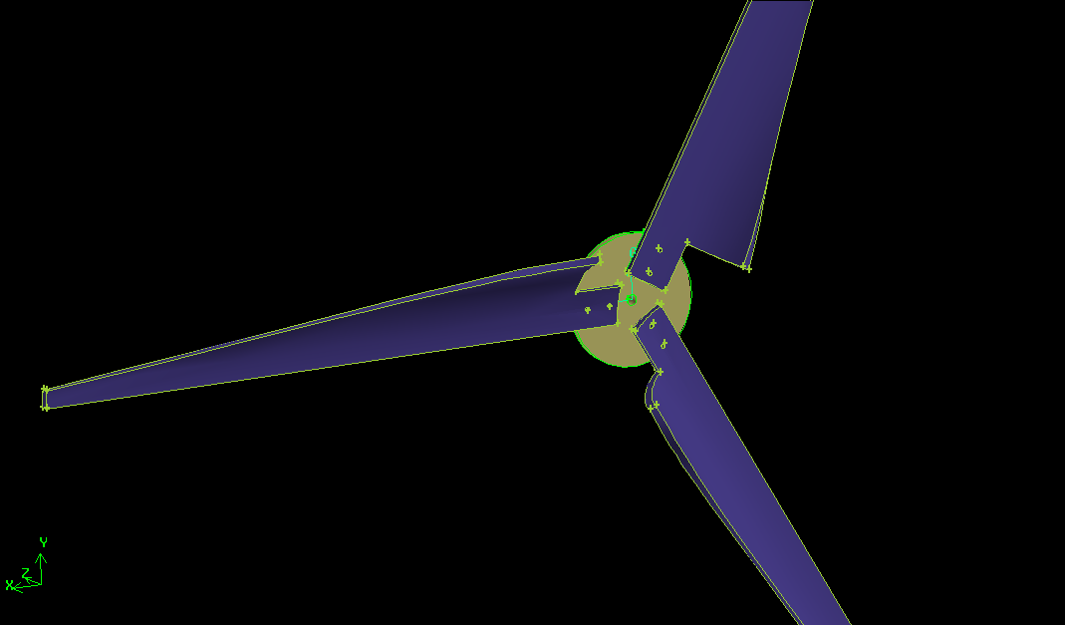Finally a postprocessor is used for the analysis and visualization of the resulting solution.

Using Ansys fluent to simulate your mechanism takes many process, it begins by drawing the problem on Gambit as shown in the figure below, and then we subtract the mechanism from the main fluid domain, that will leave a drawing that represents the air or the fluid.

The Next step is meshing the fluid, to small squares.
That will make the simulation ready for the next step which is the calculation using Fluent.
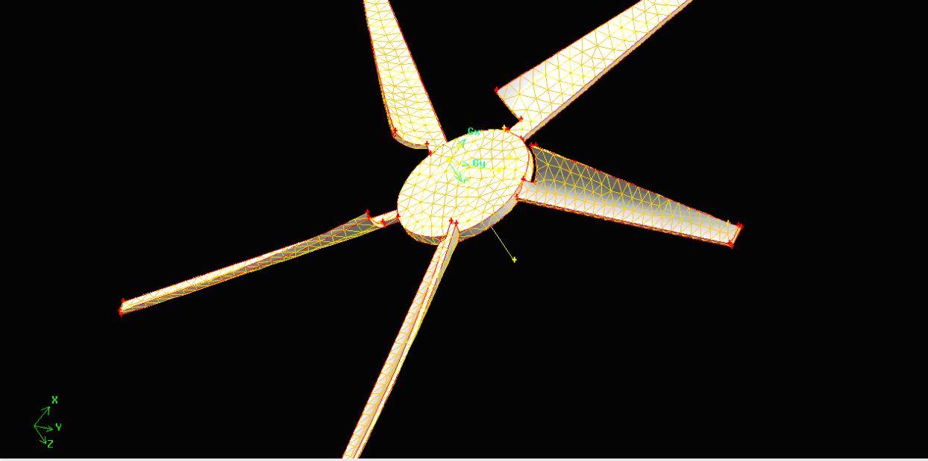
Meshing process on Gambit
4.5 Results of Ansys Fluent on NACA 2412:
In Figure 2, we can see the contours of pressure coefficient, the red colors indicate the high pressure under the blade, the blade is NACA 2412 with an angle of attack:2.
The Blue colors indicate the low pressures, the diffrence in pressures causes the turbine to rotate.

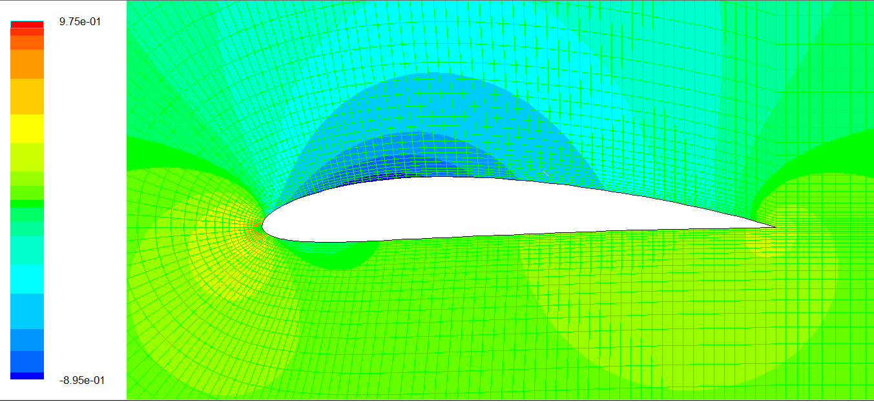
Figure 2

In Figure 3 we can see the velocity vectors on an airfoil, showing high velocities over the blade and relativaly low velocities under the blade.
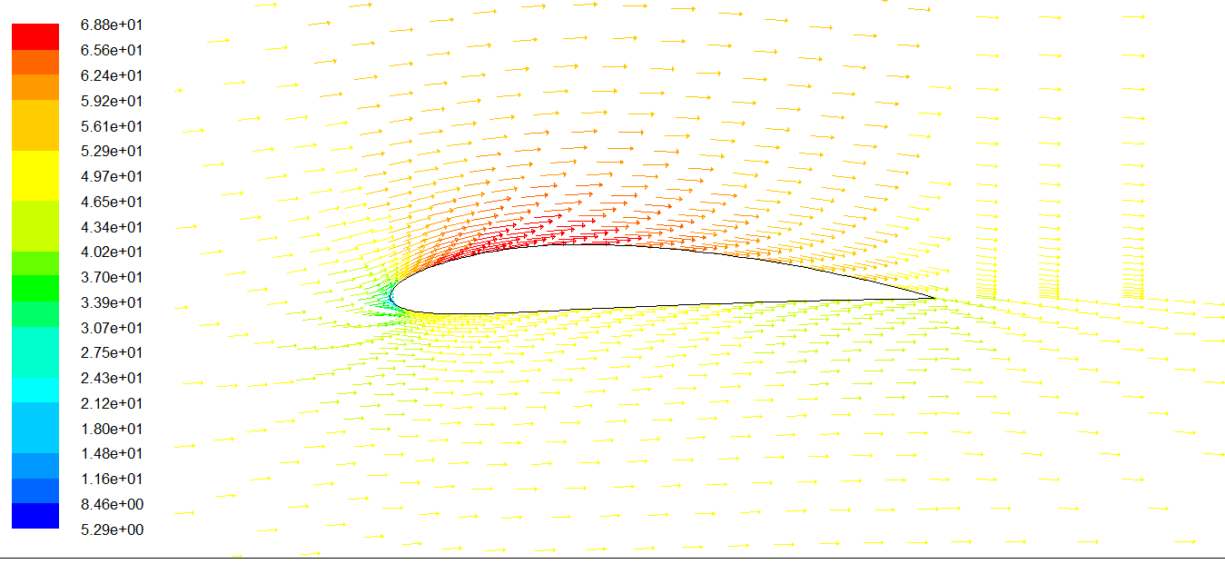
Figure 3
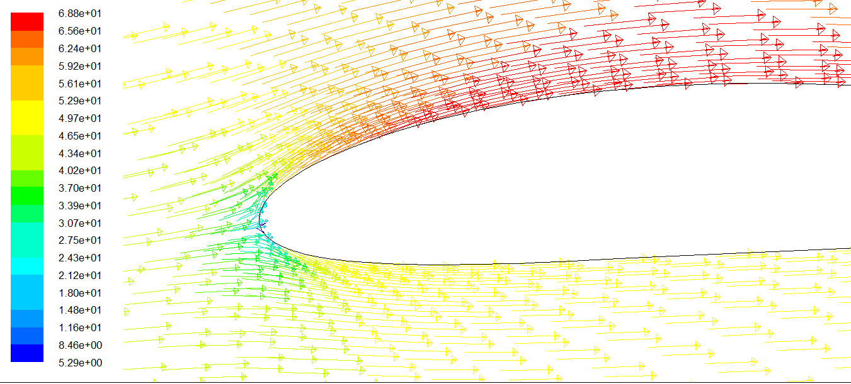
Figure 4

Fig4: Shows the leading Edge of the airfoil, the blue point shows the stgnation point.

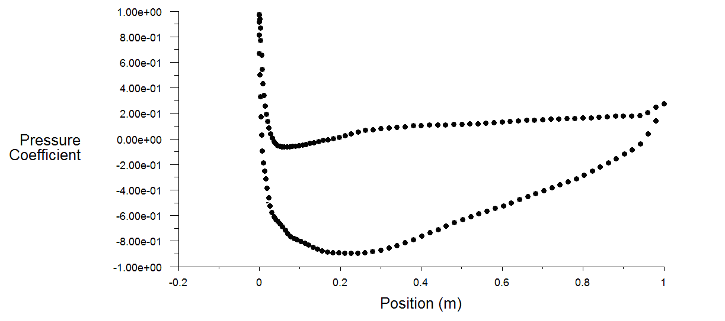
That graph shows a relation between the position on the blade and pressure coefficient.
4.6 Simulating the Nozzle:
The main Challenge that faced us was desiging and figuring up the dimensions of the Nozzle for maxizming the wind speed output.
Making the angle of inclination of the nozzle too big would block the wind with no purpose causing turblent waves, but in the same way making the angle too small, will minimize the air entering the nozzle.
So the best angle of inclination for the nozzle is supposed to be 45 degrees.
But the problem was in specifing the dimensions of the Nozzle, so we tried many nozzles with different dimensions untill we found the nozzle with dimensions that give the best performance.
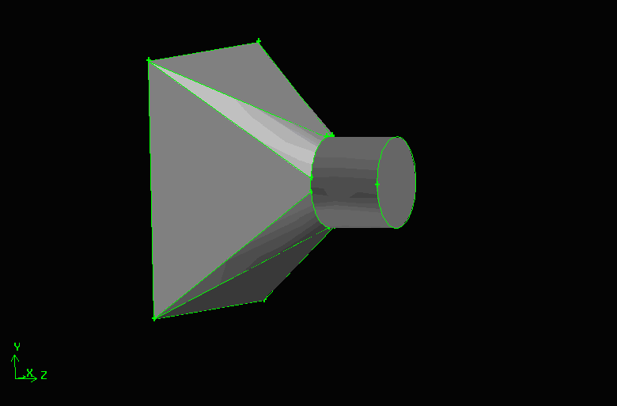
The first trial was a nozzle with the following Dimensions
Inlet Area 2 * 2 m 2 outlet : circle with dim 0.5 m , attached with tunnel of length 0.4 m
Depth of Cube : 0.75 m
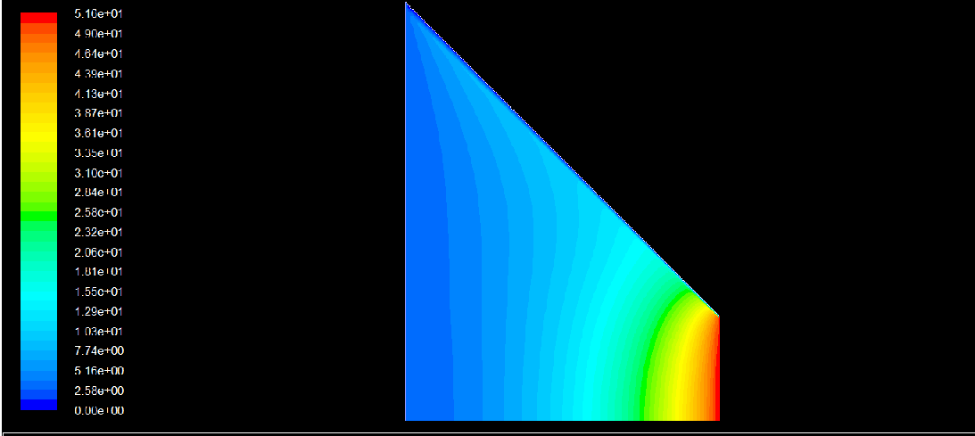
The second trial was a nozzle with the following dimensions:
Inlet area :2*2 m (square) Outlet circle with 0.5m diameter
Depth 0.75m
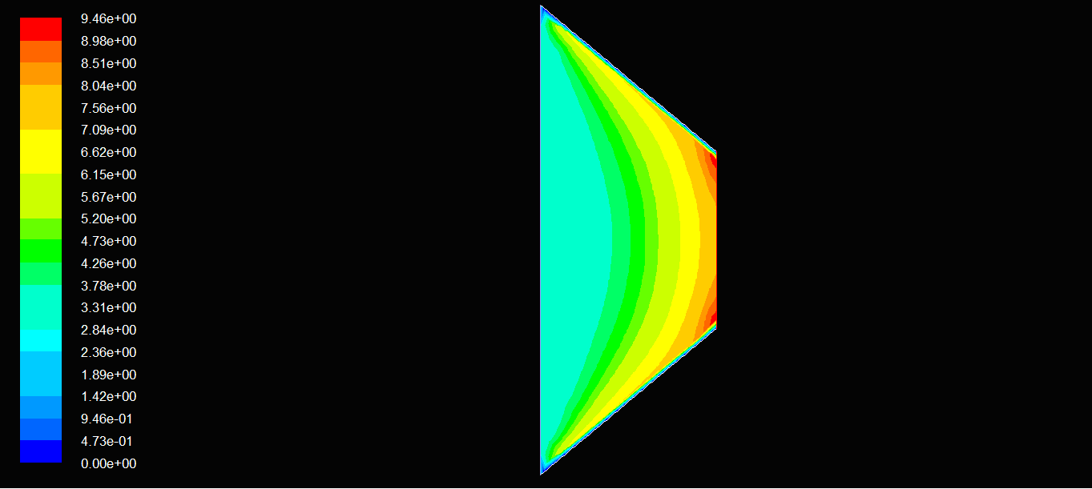T
the Conclusion that we can see in the first trial the outlet flow is very uniform and with the highest speed, so the first model was chosen.
4.7 CFD for a nozzle with 3 blades:
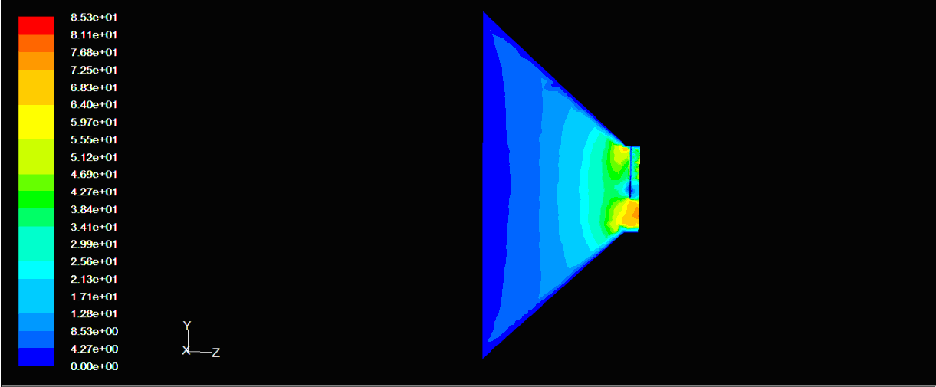
Contours of velocity magnitude-three blades
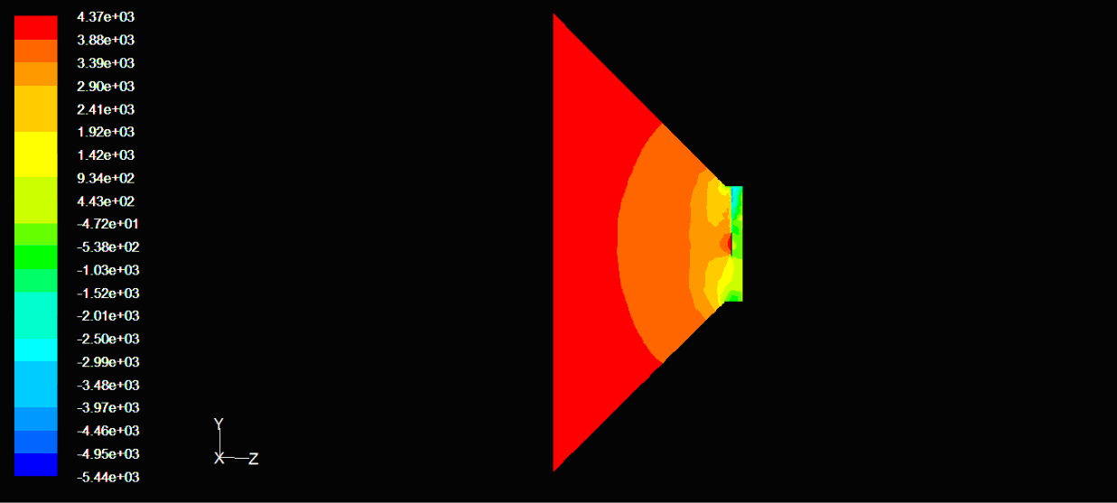
Countours of pressure- 3 blades

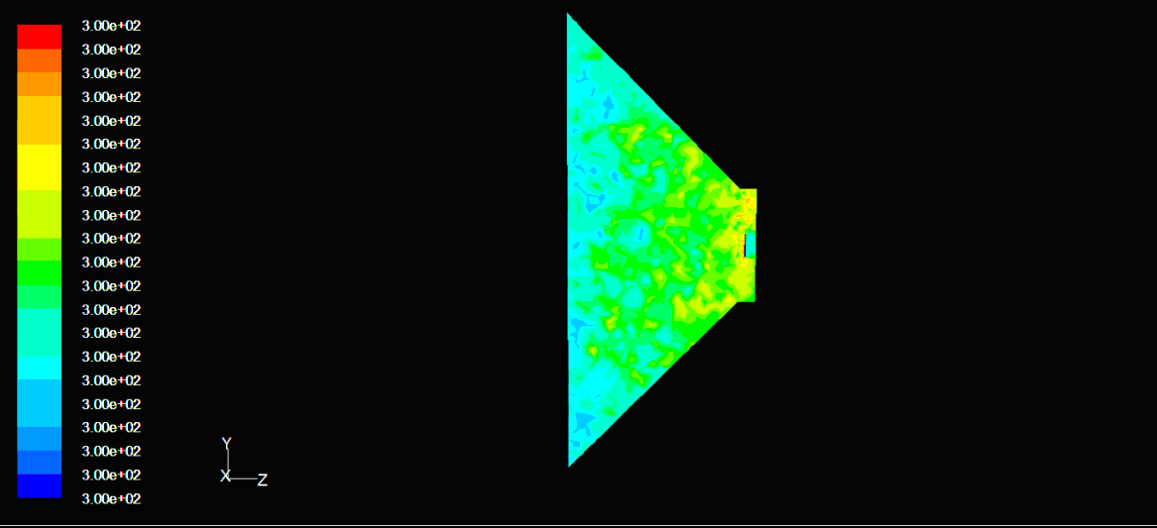
Contours of temperature- 3 blades
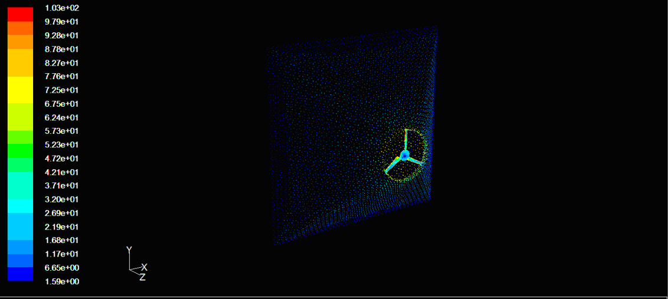
4.8 CFD for a nozzle with 5 blades
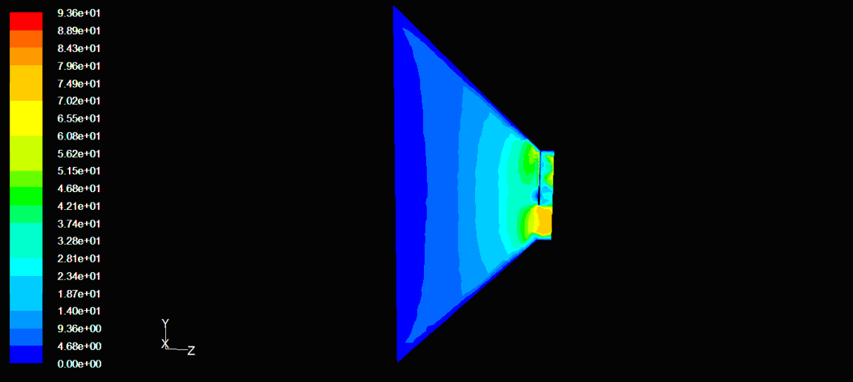
Contours of velocity- 5 blades 1

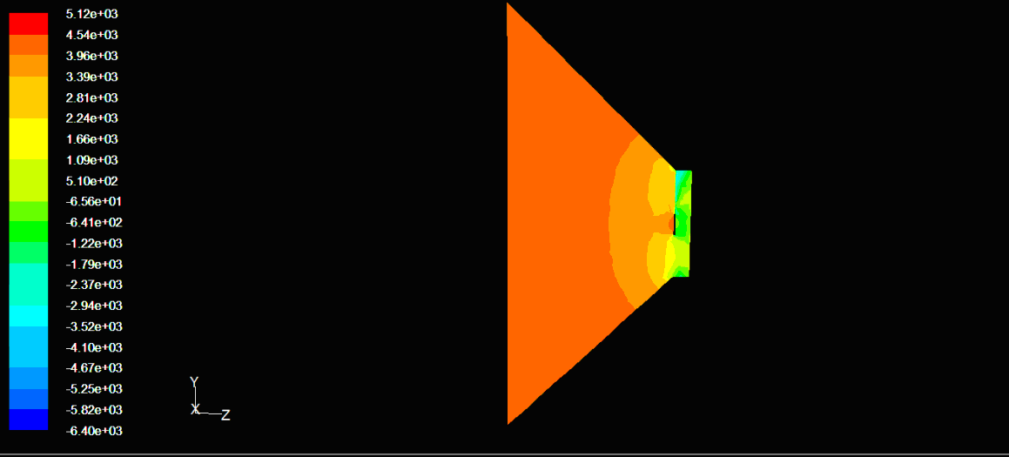
Contours of pressure- 5 blades

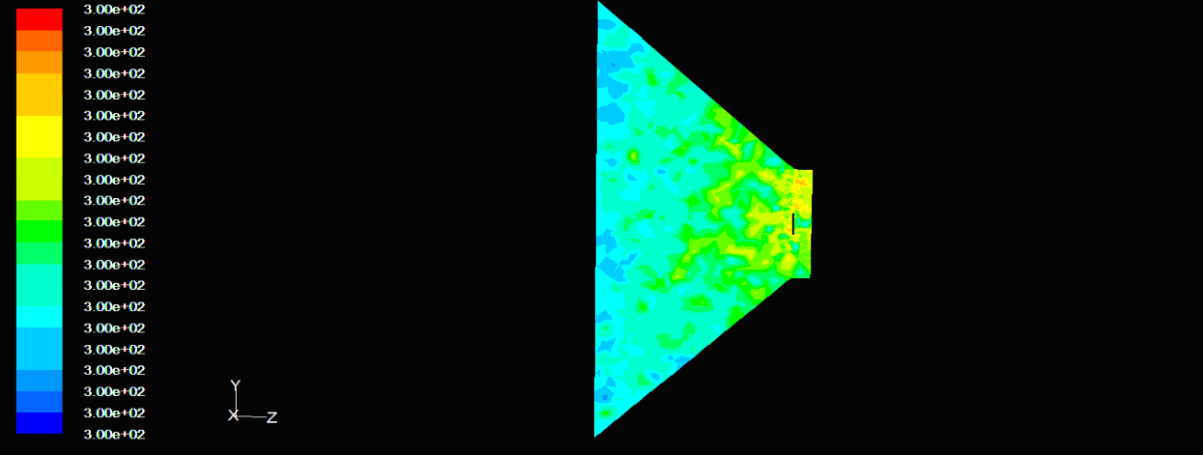
Contours of temperature - 5 blades
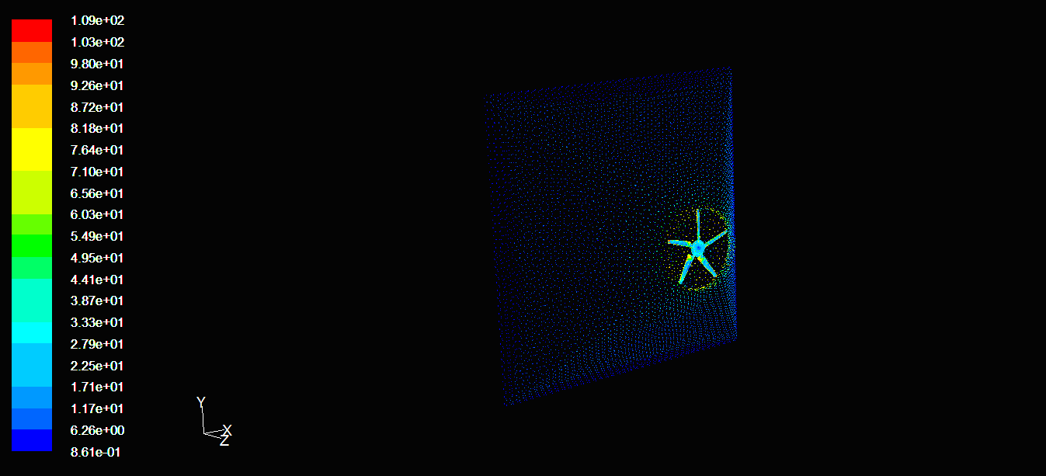
4.9 Effect of tunnel with nozzle
